COMMUNITY EMPOWERMENT (SCOTLAND) ACT 2015 FALKIRK COUNCIL ASSET TRANSFER REQUEST FORM
IMPORTANT NOTES:

This is an application form which can be used to make an Asset Transfer request to Falkirk Council.
Any Community Body interested in making an Asset Transfer Request is advised to contact the Asset Team on strategicpropertyreview@falkirk.gov.uk before making the request so that we can discuss your proposal.
Please complete the asset transfer request form if the property/land is owned/leased/managed by Falkirk Council.
It is essential that you read the Asset Transfer guidance provided by the Scottish Government before making a request.
When completed, this form should be emailed to strategicpropertyreview@falkirk.gov.uk or sent to
The Asset Team Falkirk Council 4 Stadium Way Falkirk
FK2 9EE

Section 1: Information about the Community Transfer Body (CTB) making the request
  - Name of the CTB making the asset transfer request
Polmonthill Community Snowsports Centre
  - CTB address. This should be the registered address, if you have one.
Postal address: [REDACTED]

Postcode: [REDACTED]
  - Contact details. Please provide the name and contact address to which correspondence in relation to this asset transfer request should be sent.
Contact name: [REDACTED]

Postal address: [REDACTED]
Postcode: [REDACTED]
Email: [REDACTED]

Telephone: [REDACTED]
 We agree that correspondence in relation to this asset transfer request may be sent by email to the email address given above. (Please tick to indicate
agreement)
You can ask Falkirk Council to stop sending correspondence by email, or change the email address, by telling them at any time, as long as 5 working days’ notice is given.

  - Please mark an “X” in the relevant box to confirm the type of CTB and its official number, if it has one.

 | Company and its company number is ………….
X | Scottish Charitable Incorporated Organisation (SCIO) and its charity number is ……………….. | SC053161
 | Community Benefit Society (BenCom) and its registered number is ………………………………
 | Unincorporated organisation (no number)

Please attach a copy of the CTB’s constitution, articles of association or registered rules.
Please note that under The Community Empowerment (Scotland) Act 2015, where a CTB is seeking ownership rather than a lease, the organisation must have at least 20 members. See the Scottish Government’s Guidance for Community Transfer Bodies.
  - Has the organisation been individually designated as a community transfer body by the Scottish Ministers?

Yes ☐

No
Please give the title and date of the designation order:

  - Does the organisation fall within a class of bodies which has been designated as community transfer bodies by the Scottish Ministers?
No ☐

Yes

If yes what class of bodies does it fall within?
Section 80(1)(b) “it is a Scottish charitable incorporated organisation the constitution of which includes provision that the organisation must have not fewer than 20 members”.

Section 2. Information about the land and rights requested
  - Please identify the property/land to which this asset transfer request relates.

You should provide a street address or grid reference and any name by which the land or building is known. If you have identified the land on the relevant authority’s register of land, please enter the details listed there.
It may be helpful to provide one or more maps or drawings to show the boundaries of the land requested. If you are requesting part of a piece of land, you must attach a map and give a full description of the boundaries of the area to which your request relates. If you are requesting part of a building, please make clear what area you require. A drawing may be helpful.
Details of Property: Outdoor ski and nursery slopes, with associated grounds and buildings including, main centre building, bungalow, building at bottom of slope, building next to main centre. 50% of the carpark with shared access maintained with Grangemouth Golf Club
Address: Polmonthill Ski Centre, Polmont, Falkirk Postcode: FK2 0YE

  - Please provide the UPRN (Unique Property Reference Number), if known.
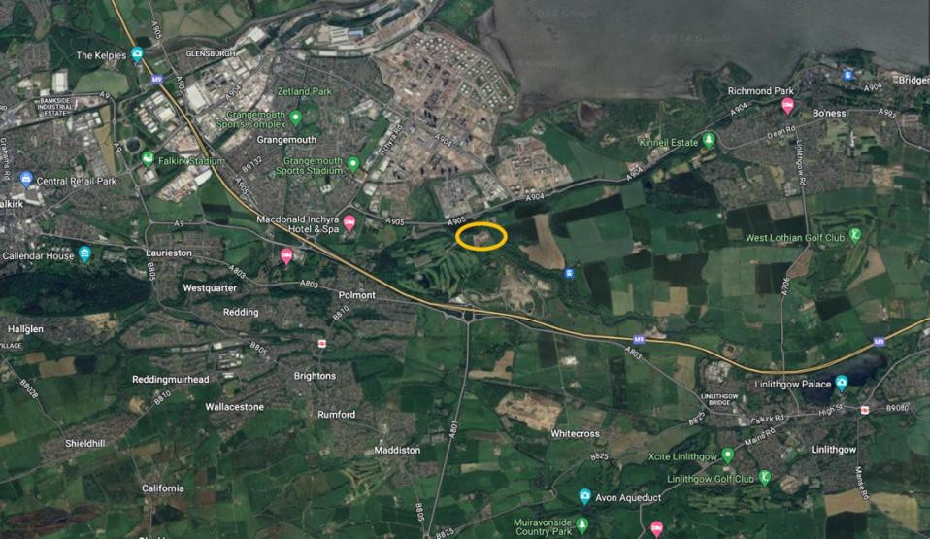
UPRN: 136054803 and 136054805

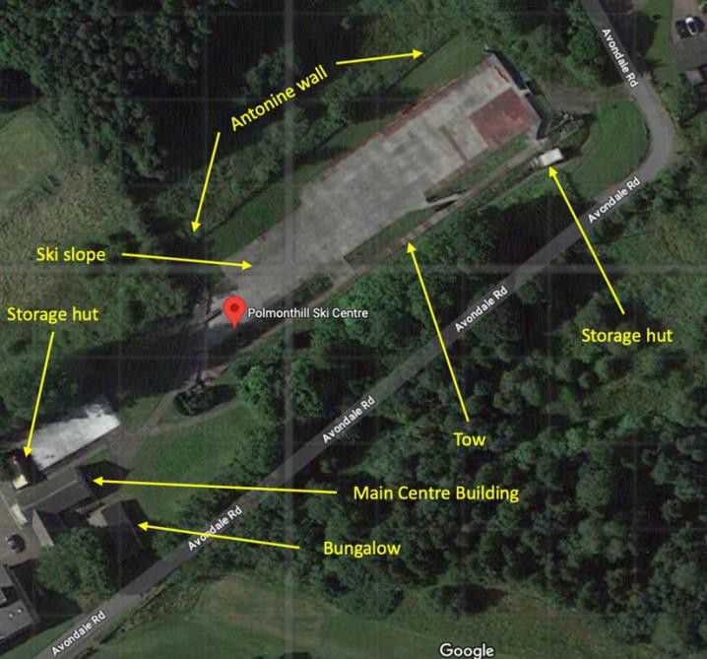

Section 3. Type of request, payment and conditions
  - Please tick what type of request is being made:

 for ownership (under section 79(2)(a)) - go to section 3A

 for lease (under section 79(2)(b)(i)) – go to section 3B for other rights (section 79(2)(b)(ii)) - go to section 3C

3A – Request for Ownership
What price are you prepared to pay for the land requested?
Proposed price: £1
Please attach a note setting out any other terms and conditions you wish to apply to the request.

The Car park and access road are currently owned by Falkirk Council and shared with the Grangemouth Golf Club, and as such the access road will have shared

responsibility for repair and maintenance. We request ownership for 50% of the carpark.

3B – Request for Lease
What is the length of lease you are requesting?

How much rent are you prepared to pay? Please make clear whether this is per year or per month.
Proposed rent: per annum
Please attach a note setting out any other terms and conditions you wish to be included in the lease, or to apply to the request in any other way.

3C – Request for other Rights
What are the rights you are requesting?

Do you propose to make any payment for these rights?

Yes ☐
No ☐
If yes, how much are you prepared to pay? Please make clear what period this would cover, for example per week, per month, per day?

Proposed payment: £ per

Please set out any other terms and conditions you wish to apply to the request.

Section 4. Community Proposal
  - Please set out the reasons for making the request and how the land or building will be used.
This should explain the objectives of your project, why there is a need for it, any development or changes you plan to make to the land or building, and any activities that will take place there.

    - Objectives of Project.
Our primary objectives are to sustainably operate the snowsports centre providing high-quality, affordable opportunities to participate in snowsports to people in Polmont and the wider Falkirk area. We aim to create a thriving snowsports community hub while ensuring a financially secure future for the Centre. In order to meet these term objectives, we aim to:
      - Increase annual visitation.
      - Maximise the potential income from non-skiing attendees/spectators.
      - Rationalise and reorder opening and staffing hours including instructor availability to match customer needs as they are not currently conducive to the operating times of our snowsports centre.
      - Enhance customer experience by maximising the full facility to generate sufficient revenue to cover operational costs, ensure improvements and long-term sustainability.
      - Develop effective marketing strategies to attract new customers and increase brand visibility.
      - Collaborate with local businesses and organisations to establish partnerships and enhance the venue's offerings.
      - Improve IT with website offering communications, and calendar with booking and payment system.
All profits will initially be reinvested into the Centre to ensure its growth and sustainability. Once the Centre has firmly established itself as a premier venue for snowsports activities and maintains consistent financial performance, the Trustees plan to initiate snowsports scholarship programs. These programs will support our talented youth, helping them advance from local training facilities to representing Scotland and the UK in national and international competitions. Our goal is to nurture and propel our most promising athletes from mat to mountain and beyond, delivering opportunities that are currently unavailable.
4.1.2 Why there is a need for your Project?
The need for the project outlined in the document revolves around the revitalisation of the Polmonthill Ski Centre, which has been underutilised and poorly maintained in recent years. The key reasons for the project include:

Community Facility: The Centre is a unique community sports facility which has the potential to serve as a vital community hub, providing recreational opportunities, particularly in snowsports, for people of all ages and socio-economic backgrounds in the Falkirk and surrounding areas.
Health and Well-being: The Centre offers important physical and mental health benefits through its activities, promoting a more active lifestyle and providing a space for social interaction, which aligns with the broader goals of public health and community cohesion.
Social Inclusion: By making snowsports accessible to individuals with socio- economic disadvantage and disabled people, the project aims to reduce social inequalities and provide inclusive opportunities to participate in a sport that is typically associated with more affluent communities.
Skill Development and Talent Nurturing: The Centre is not just a recreational facility but also a hub for skill development. It aims to nurture local talent and provide pathways for young athletes, potentially leading them to represent the region or country in competitive sports.
Educational Opportunities: The Centre plans to collaborate with local schools, providing unique educational programs that many schools cannot offer independently. This enhances the physical education curriculum and supports the overall development of students.
Facility Revitalisation and Sustainability: The project seeks to make necessary upgrades to the existing infrastructure, ensuring safety, improving usability, and making the facility more attractive to visitors. This includes plans for renewable energy installations and structural repairs, ensuring long-term sustainability avoiding current plans to mothball the facility.
    - Will any Development/changes/modifications to the asset be required?
The development changes and modifications proposed for the Polmonthill Community Snowsports Centre are comprehensive and are part of a 5 year plan to enhance the facility’s appeal, safety, and functionality. These changes are designed to attract more visitors, improve the customer experience, and ensure the long-term sustainability of the Centre. Here’s a breakdown of the key development plans:
Slope and Activity Enhancements
      - Extension of the Main Slope: The length of the main slope will be increased towards the centre building. This extension will allow for more advanced training and cater to a wider range of skiing abilities.
      - Creation of a New Tubing Slope: A dedicated tubing slope will be constructed, offering an additional fun and accessible activity for families and groups, which is expected to attract more visitors.
      - Nursery Slope with Magic Carpet: A new nursery slope will be created, complete with a magic carpet travelator. This will cater to beginners and younger children, making it easier for them to learn and enjoy skiing.
Facility Improvements
      - Café Seating Area: In the short term, the main building will be upgraded to include a seating area with hot drinks facilities. This addition will enhance the visitor experience by providing a place to relax and enjoy refreshments.
      - CCTV Installation: Security and customer viewing will be improved with the installation of CCTV cameras. This will allow for better safety management and enable parents to watch their children from the café.
      - Secure and Vandal-Proof: The existing storage huts will be upgraded with enhanced security measures to make them fully vandal-proof, ensuring the
protection and longevity of the stored equipment. Additionally, a perimeter

fence will be installed around the site to safeguard valuable equipment and prevent unauthorised access.
- Shipping Containers for Equipment and Viewing: Shipping containers will be positioned at the top of the main slope with the ground floor used for equipment storage and servicing. Additional containers will be stacked on top to create an undercover viewing area with views of the main slope, tubing slope, and nursery slope. The upper area will also include a seating area with limited café facilities and Wi-Fi hotspot. These additions will enhance the visitor experience by providing a community spirited place to relax and enjoy refreshments while family members enjoy the slopes.
Building Modifications
- Revamping the Bungalow: The bungalow next to the main building will undergo significant changes. It will be converted into a multi-functional space, including a drying room, kitchen area, office, meeting/training room, and a space for kids’ clubs and other activities. This will diversify the offerings during holiday clubs and improve the overall appeal of the Centre.
- Revamping the Main Centre: The building will undergo a transformation to bring to modern standards including the internals of the facility which have suffered through lack of investment for many years. Upgrades include, electricity rewire, new kitchen facilities, refurbished ski storage area and refurbished main desk. The ski servicing facilities will also be moved into this building to enable staff to multitask between customers and ski and snowboard maintenance
New Equipment and Training Facilities
- Treadmill Ski Machine: A new building will be constructed to house a treadmill ski machine, which will provide unparalleled training opportunities for serious skiers and snowboarders.
- Gym Equipment: Gym equipment will be added to the facility, allowing athletes to improve their fitness and ski/snowboard performance on-site.
Infrastructure Upgrades
- Roof and Structural Repairs: Significant repairs will be made to the roofs and structures of the existing buildings to address issues such as dampness and asbestos, ensuring the buildings are safe and compliant with regulations.
- Solar Panels and Renewable Energy: Solar panels will be installed on the roofs of the buildings and along the side of the nursery slope. The feasibility of incorporating a wind turbine and battery storage system will also be explored, aiming to make the Centre more sustainable by generating and storing its own energy.
- Separate Utilities: The electricity will be separated from the neighbouring Grangemouth Golf Club, ensuring that the Centre can independently manage and optimise its energy use.
Community and Recreational Additions
- Ski Shop and Servicing: A ski shop will be introduced, offering equipment rental and branded apparel. Ski servicing will also be available to both visitors and the surrounding community.
- Café and Vending Services: In addition to the café area, vending machines offering hot drinks and snacks will be added, enhancing visitor amenities.
- Event and Social Space: The Centre will include spaces for hosting events,
competitions, and social gatherings, such as BBQs, family days, and school holiday clubs, increasing its role as a community hub.

Collaboration and Education
- Collaboration with Historic Scotland: The Centre plans to collaborate with Historic Scotland to rejuvenate the nearby Antonine Wall, a UNESCO World Heritage Site, promoting its history and educating visitors about this significant landmark.

Safety and Accessibility
- Safety Improvements: New crash barriers and fencing will be assessed and repaired or replaced as necessary to ensure the safety of visitors. A layby will be created at the bottom of the slope for ambulance access in case of emergencies.
- Accessibility Enhancements: The Centre will continue to make improvements to ensure accessibility for all visitors, including those with disabilities.

These planned developments and modifications are designed to modernise the Polmonthill Community Snowsports Centre, making it a premier destination for snowsports in Central Scotland. The upgrades will not only improve the visitor experience but also ensure the Centre’s long-term sustainability and community value.
4.1.4 What activities will take place? Skiing, Snowboarding and Tubing.
4.1.5. If the asset is to be used by the public, please provide details of lettings policy and opening times.
The proposed opening times are to maximise customer accessibility and ensure profitability.

Term Time (Core Profit-Making Hours):
- Monday to Thursday: 16:00 to 21:00 (5 hours per day)
  - 1 lesson per hour
  - Total: Up to 20 hours of slope time per week
- Friday: 13:00 to 21:00 (8 hours)
  - 2 lessons per hour
  - Total: Up to 16 hours of slope time
- Saturday: 09:00 to 18:00 (9 hours)
  - 2 lessons per hour
  - Total: Up to 18 hours of slope time
- Sunday: Private hire for local ski clubs (up to 8 hours)

School Holidays:
- Monday to Sunday: 09:00 to 18:00 (9 hours per day)
  - Open 7 days a week
  - Focus on holiday clubs and additional lessons
  - Total: Up to 63 hours per week during holiday periods
Additional Information:
Sunday Operations: The Centre, currently closed on Sundays, will be opened
primarily for private hire by local ski clubs, offering an additional 8 hours of slope time.

Adjustments: Operating hours are designed to be flexible and may be adjusted based on customer demand, especially during the weekdays when schools may require the facility to be open.
    - What provision will be provided for people with disabilities?
The Trustees at Polmonthill Community Snowsports Centre understand that it is societal barriers, not individual impairments or differences, that disable people. At the Centre, we are committed to identifying and removing those barriers to ensure full participation for everyone, and have outlined several provisions to ensure that disabled people can fully participate in the activities offered and enjoy the facilities. These provisions focus on accessibility, specialised equipment, and inclusive programming. Here are the key provisions:
Adaptive Snowsports Opportunities
      - Physical Exercise: The Centre will offer skiing on dry slopes as an excellent form of outdoor exercise for disabled people. Snowsports helps improve mobility, strength, and coordination while providing a recreational outlet.
      - Increased Independence: Assisted skiing opportunities will be provided to empower disabled people. These programs are designed to foster independence and a sense of accomplishment, boosting self-esteem and overall well-being.
      - Inclusive Environment: The Centre aims to create an environment where disabled people can participate alongside their able-bodied peers. This inclusive approach promotes social integration and helps break down stigmas surrounding disabilities.

Specialised Equipment
      - Adaptive Equipment: The Centre plans to acquire and maintain specialised adaptive skiing and snowboarding equipment that allows individuals with various physical disabilities to participate in snowsports. This includes sit-skis and other adaptive devices.
      - Accessible Buildings and Infrastructure: All facilities, including the main building and the bungalow, will be made accessible. This includes wheelchair-accessible entrances, ramps, and bathrooms. The modifications will ensure that everyone, regardless of physical ability, can navigate the Centre comfortably.
Trained Instructors
      - Specialised Training for Instructors: The Centre will ensure that instructors are specially trained to work with people with disabilities. This training will cover how to use adaptive equipment, provide effective instruction, and ensure the safety and enjoyment of participants.
      - Inclusive Lessons: Skiing and snowboarding lessons will be designed to accommodate various levels of ability, ensuring that disabled people receive the appropriate support and instruction.
Social Inclusion Initiatives
      - Community Engagement: The Centre plans to engage with local organisations and disability groups to promote participation in snowsports. This will help ensure that the Centre’s offerings are well-known and accessible to those who can benefit most from them.
- Affordability: The Centre is committed to making snowsports accessible to all, including those from economically disadvantaged backgrounds. This may include offering subsidised lessons or scholarships for disabled people.

Inclusive Events and Competitions
- Adaptive Sports Competitions: The Centre may host adaptive sports competitions specifically for individuals with disabilities, creating an inclusive environment where everyone can compete and enjoy snowsports.
4.1.7 Any other relevant information?

No

Benefits of the proposal
  - Please set out the benefits that you consider will arise if the request is agreed to.
Local Authorities are permitted to dispose of property at less than market value where there are wider public benefits to be gained. This is set out in the Disposal of Land by Local Authorities (Scotland) Regulations 2010. These public benefits are listed below.
In this section, please explain how the project will benefit your community, and others. Please refer to the Scottish Government guidance on how the Council will consider the benefits of a request.

Please explain how the project will benefit your community by detailing how your project will promote or improve:
4.2.1. Economic development/income generation

i.e.. Please include details of any job creation or volunteering and training opportunities that will be available as a result of the Asset Transfer. Also details of how your organisation will involve the local community and of any incentives that may be available to encourage the local community to use the proposed services.

Job Creation
Direct Employment: The Centre will employ a range of staff, including ski instructors, administrative personnel, maintenance workers, and potentially café staff. This will provide direct employment opportunities residents in the surrounding area.
Volunteer Opportunities: Specifically at the start, the Centre plans to engage volunteers, offering them valuable experience and skills development that can enhance their employability in the future.

Long-term Economic Impact
Sustainable Economic Growth: The Centre’s operations are designed to be sustainable, with profits being reinvested into further development and scholarship programs. This approach ensures that the economic benefits are long-lasting, supporting not only the local economy well into the future, but contributing to a healthy snowsports future for both Scotland and the UK.
Reducing Economic Disparities: The Centre’s focus on inclusivity, particularly for individuals from deprived areas, helps to reduce economic disadvantage by providing affordable access to sports and recreational activities that are typically more expensive.

Cost Savings for the Local Government
Reduced Maintenance Costs: By taking over the operation of the Centre through a Community Asset Transfer, the local government (Falkirk Council) will save on the costs associated with

maintaining and operating the facility. These savings can be redirected to other community needs or services.
Volunteer Contributions: The Centre’s use of volunteers will provide significant cost savings in terms of staffing, which contributes to the overall economic viability of the Centre.
4.2.2. Regeneration
i.e. Please include details of whether your organisation will contribute to the physical regeneration of the area, and how your proposal will impact the regeneration of the area, in terms of volunteering or employment, giving examples.

Physical Regeneration of the Area
Revitalising a Neglected Facility: The project involves the comprehensive renovation of the Polmonthill Ski Centre, which has suffered from years of underinvestment. By upgrading the facility’s infrastructure, including the ski slopes, buildings, and surrounding areas, the project will transform a neglected asset into a vibrant community hub.
Enhanced Aesthetics and Usability: The upgrades will include modernising the buildings, improving landscaping, and installing new amenities such as a limited café, nursery slope, and tubing facilities. These changes will enhance the overall aesthetics of the area, making it more attractive to visitors and residents alike.

Direct Employment Opportunities:
Construction and Renovation Jobs: The regeneration project will require skilled and unskilled labour for the construction, renovation, and maintenance work. This will create temporary employment opportunities for local contractors, builders, electricians, plumbers, and other tradespeople.
Long-term Operational Jobs: Once the Centre is fully operational, it will create permanent jobs, including roles for ski instructors, administrative staff, maintenance workers and café staff. These positions will provide stable employment for locals in the surrounding community.
Apprenticeships and Training Programs: The Centre may offer apprenticeships and on-the-job training opportunities in areas such as sports instruction, facility management, and customer service, helping to build skills and employment prospects for young people in the area.

Indirect Employment Opportunities:
Supplier Partnerships: The Centre will require ongoing supplies of goods and services, from sports equipment to food and beverages. Local suppliers will benefit from contracts to provide these goods, creating further employment opportunities.

Volunteer Engagement and Skill Development:
Volunteer Programs: The Centre will engage volunteers in various roles, providing them with valuable experience that can enhance their employability. Volunteers will be involved in event management, customer service, maintenance, and community outreach programs.
Pathways to Employment: By offering training and experience through volunteer roles, the Centre will help individuals develop skills that are transferable to paid employment, thus contributing to long- term workforce development in the region.

Long-term Economic Sustainability
Self-sustaining Operations: The Centre aims to be financially self-sustaining, with profits reinvested into further developments and scholarships for our most talented and determined youth. This sustainable business model ensures that the Centre can continue to contribute to the local economy without relying on ongoing external funding.
4.2.3. Public Health
i.e. How likely is the proposal to improve the Public Health of the Community, in terms of physical and mental health, for example through volunteering, training, or taking part in activities, giving examples.

Physical Health Benefits Regular Physical Activity:
Cardiovascular Health: Snowsports like skiing and snowboarding are excellent forms of cardiovascular exercise. Engaging in these activities regularly can help improve heart health, increase lung capacity, and enhance overall cardiovascular endurance.

Muscle Strength and Endurance: Skiing and snowboarding require the use of multiple muscle groups, particularly the legs, core, and upper body. Regular participation helps to build muscle strength, improve balance and coordination, and increase overall physical endurance.
Weight Management: The energy expenditure during snowsports is significant, which can help individuals manage their weight and reduce the risk of obesity. This is particularly important in combating the rising rates of obesity-related conditions such as diabetes and hypertension.

Improved Bone Health:
Bone Density: Snowsports are weight-bearing activities that help improve bone density, which is crucial in preventing osteoporosis and other bone-related conditions, especially as individuals age.

Flexibility and Coordination:
Enhanced Coordination: The balance and agility required for skiing and snowboarding improve coordination and spatial awareness. This can reduce the risk of falls and injuries in everyday life, particularly for older adults.
Flexibility: The range of motion involved in these activities promotes flexibility, which is important for overall joint health and mobility.

Encouraging Outdoor Activity:
Exposure to Fresh Air: Outdoor activities like skiing and snowboarding encourage participants to spend time in natural environments, which can lead to better physical health outcomes compared to sedentary indoor activities.
Sunlight and Vitamin D: Time spent outdoors also increases exposure to sunlight, which is vital for vitamin D synthesis, important for bone health and immune function.

Mental Health Benefits Stress Reduction:
Natural Stress Reliever: Physical activity, particularly in outdoor settings, is known to reduce stress levels. The combination of physical exertion and the calming effects of being in nature can significantly lower cortisol levels, leading to improved mental well-being.
Mental Relaxation: The focus required in skiing and snowboarding helps participants clear their minds, providing a form of active meditation that can reduce anxiety and depression symptoms.

Improved Mood:
Endorphin Release: Exercise, such as snowsports, stimulates the release of endorphins, often referred to as “feel-good” hormones. These endorphins improve mood and can help combat symptoms of depression.
Social Interaction: The social aspects of snowsports, such as group lessons, competition and club activities, foster a sense of community and belonging, which can combat feelings of loneliness and isolation, particularly important in today’s digital age.

Boosted Self-Esteem and Confidence:
Skill Development: Learning and mastering new skills in snowsports can boost self-esteem and confidence. The sense of achievement from progressing through different levels of proficiency can have lasting positive effects on an individual’s mental outlook.
Overcoming Challenges: Snowsports often present physical and mental challenges that, when overcome, build resilience and a sense of accomplishment, contributing to a more positive self- image.

Improved Cognitive Function:
Concentration and Focus: The need to focus on balance, speed, and movement during skiing and snowboarding helps improve cognitive function, including concentration, decision-making, and problem-solving skills.
Mental Agility: The rapid decision-making required in snowsports can enhance mental agility, helping to keep the brain sharp and engaged.

Inclusive Environment:
Accessible for All: The Centre’s commitment to inclusivity, with programs tailored for people of all ages, abilities, and socio-economic backgrounds, ensures that everyone in the community can benefit from the physical and mental health advantages of snowsports.
Support for Disabled People: By offering adaptive sports and specialised programs for disabled people, the Centre promotes social inclusion and provides mental and physical health benefits to those who might otherwise have limited access to recreational activities.

Long-term Health Outcomes Lifelong Healthy Habits:
Encouraging Active Lifestyles: By introducing individuals, especially children and adolescents, to the joys of snowsports, the Centre encourages the development of lifelong healthy habits. Regular physical activity in youth is linked to continued activity in adulthood, contributing to long-term health benefits.
Preventing Chronic Diseases: Regular participation in physical activities like skiing and snowboarding can help prevent chronic diseases such as obesity, diabetes, heart disease, and mental health disorders.

Holistic Health Benefits:
Integrated Health Approach: The Centre’s programs contribute to a holistic approach to health, addressing physical, mental, and social well-being. This comprehensive health benefit helps build a resilient community, better equipped to handle the challenges of modern life.

Specific Programs to Enhance Health Outcomes
Holiday Clubs and School Programs: These programs will encourage children to participate in physical activities, promoting healthy growth and development, and instilling the importance of an active lifestyle from a young age.
Ski Racing and Competitions: Competitive events will provide both physical exercise and mental challenges, encouraging participants to set goals, work towards them, and celebrate their achievements.
Health and Well-being Workshops: The Centre could also offer workshops focused on topics like nutrition, mental health, and physical fitness, further enhancing the community’s overall well-being.
4.2.4. Social Wellbeing

i.e. How will the proposal improve the Community's Social Well-Being and mental health, or how might it improve the learning offer and activities available in the area? Please give brief examples of these activities.

Social Health and Well-being Community Engagement:
Social Interaction: The Centre will serve as a hub for social interaction, bringing people together in a positive and active environment. This can lead to stronger social networks, reducing feelings of isolation and loneliness.
Teamwork and Cooperation: Group activities and lessons promote teamwork and cooperation, essential social skills that contribute to overall mental well-being.

Community and Social Impact
Reducing Social Exclusion: By creating an inclusive environment that welcomes people from all backgrounds, including disabled people and people with socio-economic disadvantage, the Centre will help reduce social exclusion. This inclusivity can lead to improved social cohesion and a more vibrant, connected community, which is essential for long-term regeneration.
Supporting Local Youth: The Centre’s focus on youth programs, such as holiday clubs and school partnerships, will provide young people with safe, structured activities that promote physical health and social development. Engaging youth in positive activities can reduce crime rates and contribute to the overall regeneration of the area.
4.2.5. Environmental Wellbeing / Environmental Benefits

i.e. Will the proposal bring green / environmental benefits and / or have an impact on the local environment? Will it help mitigate the effects of climate change? If so please give details.

Enhancing the Area’s Profile
Boosting the Local Profile: By becoming a leading destination for snowsports in Central Scotland, the Centre will enhance the profile of the area. This increased visibility can attract tourists and investors, contributing to broader economic regeneration efforts.
Cultural and Historical Promotion: The Centre’s collaboration with Historic Scotland to rejuvenate and promote the nearby Antonine Wall, a UNESCO World Heritage Site, will help to preserve and
highlight the area’s cultural heritage. This will further increase tourism and educational opportunities, adding to the area’s regeneration.

Community Hub Development: The Centre will serve as a community hub, offering not just sports activities but also social spaces, educational programs, and cultural events. This multifunctional use of the facility will contribute to the physical and social regeneration of the area, making it a focal point for community life.
Environmental Improvements: The installation of sustainable energy solutions, such as solar panels and potentially wind turbines and batteries, will contribute to the environmental regeneration of the area. These improvements will not only reduce the carbon footprint of the Centre but also serve as a model for sustainable practices in the community.
4.2.6. Does your project contribute to the reduction of inequalities?

i.e. Will the proposal enable the community to access activities not otherwise available; will these activities be available at an affordable rate; how will your organisation work with other local providers to reduce inequalities?
Yes
Economic Accessibility
Affordable Access to Snowsports: Snowsports are often associated with high costs due to expensive equipment, travel, and accommodation, making them inaccessible to many people, particularly those from lower socio-economic backgrounds. By offering affordable lessons, equipment rental, and subsidised programs, the Centre will make snowsports accessible to a wider segment of the population, including those who may otherwise not have had the opportunity to participate.
Subsidised Programs: The centre plans to provide reduced cost programs for individuals from socio-economically disadvantaged backgrounds. This could include discounted or free lessons, and access to events, ensuring that financial constraints do not prevent anyone from enjoying the benefits of snowsports.
Scholarships: The project aims to establish scholarships and funding opportunities to support talented individuals who may not have the financial means to pursue snowsports at a competitive level. This initiative will help level the playing field, allowing talent to flourish regardless of economic background.

Social Inclusion
Programs for Disabled People: The Centre is committed to providing adaptive equipment and specialised programs for disabled people. By ensuring that people with physical or learning disabilities can participate in snowsports, the project promotes social inclusion and challenges the barriers that often prevent disabled people from engaging in recreational activities.
Inclusive Environment: The centre will foster an environment that welcomes individuals from all backgrounds, including those from marginalised or minority communities. By offering programs that are culturally sensitive and inclusive, the Centre will help bridge social divides and bring together people from different walks of life.
Targeting Deprived Areas: The Centre will actively engage with schools and community groups in deprived areas, providing outreach programs and transportation options to ensure that children and young people from these areas can participate in the activities offered. This approach will help address the geographic and socio-economic barriers that often limit access to recreational and sporting opportunities.

Gender Equality
Encouraging Female Participation: Recognising the gender gap that often exists in sports, particularly in male-dominated activities like snowsports, the Centre will offer programs specifically aimed at encouraging female participation. This could include women-only classes, mentoring programs, and promotional campaigns to inspire and empower women and girls to engage in snowsports.
Role Models and Representation: By highlighting successful female athletes and instructors, the Centre will promote positive role models for young girls, demonstrating that snowsports are for everyone, regardless of gender.

Youth Engagement and Development
Accessible Youth Programs: The Centre will offer youth programs, such as school holiday clubs and after-school lessons, at affordable prices. These programs will provide young people, especially those from disadvantaged backgrounds, with constructive activities that promote physical and mental well-being, helping to reduce youth crime and antisocial behaviour.
Skill Development and Education: Through collaboration with local schools, the centre will offer educational programs that integrate physical education with snowsports. This not only promotes

physical health but also supports the development of skills such as teamwork, discipline, and leadership, which are critical for personal and academic success.

Reducing Health Inequalities
Health and Well-being Initiatives: The Centre’s focus on providing accessible recreational opportunities will help address health inequalities by promoting physical activity among members of the population that may have limited access to sports facilities. Regular physical activity is linked to better health outcomes, and by making it accessible to all, the Centre will contribute to reducing the disparities in health outcomes between different socio-economic groups.
Mental Health Support: By providing a space for social interaction, physical activity, and stress relief, the Centre will contribute to better mental health outcomes for the community. This is particularly important for individuals from deprived backgrounds who may be at higher risk of mental health issues due to economic and social stressors.

Community Empowerment
Engaging Local Residents: The project will empower local residents by involving them in the management and operation of the Centre. This could include opportunities for volunteering, governance roles within the community organisation, and input into program development. By giving the community, a stake in the Centre, the project promotes a sense of ownership and responsibility, which is key to reducing social inequalities.
Building Social Capital: The Centre will serve as a community hub, fostering connections between individuals from diverse backgrounds. These connections can lead to increased social capital, where people support each other, share resources, and work together to improve their community.

Long-term Economic Impact
Job Creation: By creating jobs and offering volunteer opportunities, the Centre will contribute to reducing economic inequalities in the local area. Employment opportunities will be made available to individuals from all backgrounds, including those who may face barriers to employment, such as disabled people or those from disadvantaged socio-economic groups.
Pathways to Further Opportunities: Through training programs, apprenticeships, and skill development initiatives, the Centre will provide pathways to further education and employment, helping to break the cycle of poverty and disadvantage.

Promoting Diversity and Cultural Awareness
Culturally Inclusive Programs: The Centre will develop programs that are sensitive to the cultural needs and preferences of different community groups. By promoting cultural awareness and inclusivity, the centre will help to reduce racial and ethnic inequalities, creating a space where diversity is celebrated.
Community Events and Celebrations: Hosting community events that celebrate different cultures and traditions will further promote understanding and respect among diverse groups, helping to build a more inclusive and equitable community.

Environmental Justice
Sustainable Practices: The Centre’s commitment to environmental sustainability will ensure that the benefits of a healthy environment are accessible to all members of the community, not just those in more affluent areas. By promoting eco-friendly practices, the Centre will contribute to the overall well-being of the community, ensuring that everyone has access to clean, safe, and green spaces.
4.2.7 Will local people be engaged in the use and management of the Asset?
A “community of interest” may not represent the people living near to the asset. Please provide evidence of how local people and communities will be engaged in the use and management of the asset, and how they have been consulted.

Yes, local people will be actively engaged in both the use and management of the Polmonthill Community Snowsports Centre. The Centre will be run as a community asset, with opportunities for local residents to participate in decision-making through volunteer roles, governance positions, and input into program development. Additionally, the Centre will offer accessible programs and activities designed to meet the needs of the local community, ensuring that it serves as a vibrant hub for local engagement and involvement.

The Trustees have actively engaged with members of the local community in developing its plans. This has included collaboration and consultation with existing users of the Centre through the
Polmonthill Snowsports Club and having stalls at the slope during recent events. Members of other local community groups, associations and schools have also been engaged. The group has made

extensive use of social media and local print and radio media to inform the community of its plans and encourage their involvement.

All local people and community members were invited to share their views on the future of the Centre through an online survey and gather valuable insights on the expectations for the Centre ensuring the community's voice remains at the heart of this exciting transformation. With 312 responses—102 offering comments and 29 suggesting new ideas—the feedback strongly aligned with the Trustees’ vision, reaffirming our commitment to creating a facility that truly reflects and meets the needs of the local community. While 94% of respondents were from the immediate area, we also received valuable input from Perthshire and Inverness, where many of our skiers often travel for real snow experiences.

Between June 1st and September 10th, our new website (www.polmonthill.co.uk) has seen impressive engagement, with 4,810 page views and 1,399 unique visitors. This indicates strong interest, with visitors exploring multiple pages, which reflects positively on the site’s content and user experience. These numbers demonstrate growing traffic and engagement signalling the site’s potential for even greater reach and interaction and a solid customer base.
4.2.8 How will you monitor whether the Asset Transfer is benefiting the community?
i.e. Will you survey the users / invite feedback / compare user numbers with a baseline etc

Key Performance Indicators (KPIs)
Monthly and Annual Reviews: The charity will use a set of KPIs to regularly monitor performance against its goals. These KPIs will include metrics such as visitor numbers, participation rates in programs, customer satisfaction, financial performance, and community engagement levels.
Example KPIs:
Increase in Annual Visitation: Tracking the number of people using the facility to measure community uptake.
Program Participation: Monitoring the number of participants in various programs, including those targeting underrepresented groups.
Customer Satisfaction: Using surveys and feedback forms to gauge the satisfaction of users and identify areas for improvement.

Community Feedback and Surveys
Regular Surveys: The charity will conduct regular surveys of users, local residents, and stakeholders to gather feedback on the services provided and their perceived impact on the community.
Focus Groups: Periodic focus groups will be held with different segments of the community to gather in-depth insights and suggestions for improvement.

Community Engagement and Involvement
Advisory Committees: Local residents will be encouraged to join advisory committees or working groups to provide ongoing input on the Centre’s operations and community needs.
Volunteer Contributions: The charity will track the involvement of local volunteers, both in terms of hours contributed and the roles they play, to measure the level of community engagement in managing the Centre.

Social Impact Assessments
Inclusive Participation Metrics: The charity will assess the diversity of participants, particularly focusing on how well the Centre engages with economically disadvantaged groups, disabled people
, and other underrepresented communities.
Health and Well-being Outcomes: Through partnerships with local health organisations, the charity may track health outcomes related to physical and mental well-being for regular users of the Centre.

Reporting and Transparency
Annual Impact Reports: The charity will produce an annual impact report detailing the benefits to the community, including qualitative and quantitative data. This report will be made available to the public to ensure transparency and accountability.
Regular Updates to Stakeholders: Regular updates will be provided to key stakeholders, including local councils, funders, and community members, to keep them informed about the Centre’s progress and impact.

External Evaluations
Independent Audits: The charity may commission independent evaluations or audits to assess the effectiveness of its programs and the overall impact of the Centre on the community. These evaluations can provide an unbiased perspective on the charity’s success in meeting its objectives.

The scorecard we have developed is as follows
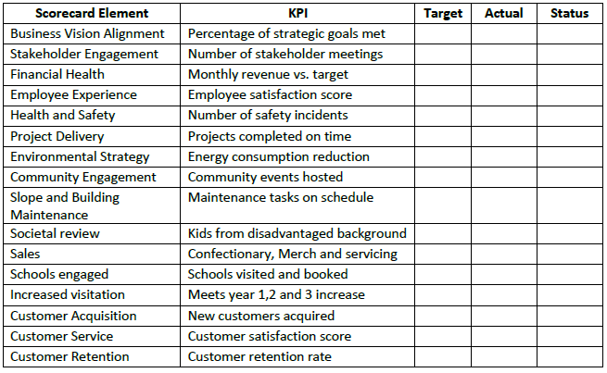

4.2.9 Any other relevant information?
No

Restrictions on use of the land
  - If there are any restrictions on the use or development of the land, please explain how your project will comply with these.
Restrictions might include, amongst others, environmental designations such as a Site of Special Scientific Interest (SSI), heritage designations such as listed building status, controls on contaminated land or planning restrictions.

The charity aims to erect a fence at the Polmonthill Community Snowsports Centre for practical purposes, but due to the proximity of the Antonine Wall, a UNESCO World Heritage Site, this must be done sensitively. The Antonine Wall is protected under strict regulations managed by Historic Scotland, which requires any development near the site to preserve its historical integrity. To proceed, the charity will consult with Historic Scotland, ensuring the fence is designed and positioned in a way that respects the wall’s significance, using materials and methods that do not harm the site, thereby balancing modern needs with heritage preservation.

Negative consequences

  - Are there any negative consequences that will affect other groups or individuals if your request is agreed to? How you propose to minimise / reduce these?
For example, increased traffic etc. Please consider any potential negative consequences for the local economy, environment, or any group of people, and explain how you could reduce these.

There are no known negative consequences to the proposal, as we do not intend to change the use of the snowsports centre.

Capacity to deliver
  - Please show how your organisation will be able to manage the project and achieve your objectives.
This could include the skills and experience of members of the organisation, any track record of previous projects, whether you intend to use professional advisers, etc.
    - Has your organisation or any of its members managed projects or owned / leased property/land prior to this?
Yes

No ☐
Please provide details of:

    - Skills and experience of the members of the organisation

The trustees:
[REDACTED] has over 40 years of skiing experience, and professional expertise in project management, process improvement, customer experience, IT development, and operational management, alongside leadership roles in youth programs with the Prince’s Trust.
[REDACTED] offers over 30 years of experience in finance and accounting, with a focus on customer service and community support, along with a personal understanding of the value of outdoor activities.
[REDACTED] brings hands-on experience in ski centre management, business management, and stakeholder engagement from her background in environmental consultancy and leadership roles in corporate and public sectors.
[REDACTED] is an experienced community sports developer and social researcher, with extensive knowledge in community engagement, development processes, and navigating funding landscapes.
[REDACTED] has over 35 years of snowboarding experience and expertise in

electrical and mechanical engineering, alongside a strong background in mentoring, problem-solving, and managing complex systems in high-pressure environments.
Together, the trustees combine their passion for snowsports with professional expertise in management, finance, community development, and engineering, ensuring effective governance and strategic direction for the Centre.
    - Do you intend to use professional advisors? Please provide details.

Yes
Accountants to manage financial matters, including completing the annual return to Legal Representation from Anderson Strathern to provide legal advice and ensure compliance with relevant regulations.
Health and Safety Advisors to ensure that all activities and facilities meet the highest safety standards, protecting both staff and visitors.
Architectural Professionals to guide the design and development of facility upgrades, ensuring that any renovations or new constructions are both functional and sensitive to the historical context of the site.
Marketing Professionals to develop and implement effective strategies to increase visibility, attract visitors, and engage the local community.
Snowsports Equipment Experts to ensure the Centre is equipped with high- quality, appropriate gear for skiing, snowboarding, and other activities, and to advise on maintenance and upgrades as needed.
    - Do you currently lease/manage a property from Falkirk Council? If yes, please provide details.
No
4.5.4 Please detail how you plan to manage the building?

For example, opening and closing the building / managing lets / will you have staff etc?
Our approach to managing the Centre will be grounded in compliance, ethical standards, and accountability. We are committed to swiftly identifying and addressing any operational or administrative issues that may arise. By exercising prudent financial management, we will ensure the long-term stability and viability of the Centre, allowing it to thrive as a community asset.
Initially, the day-to-day operations of the snowsports centre, including managing bookings, the scheduling and coordination of events, maintaining the building and ski equipment, and overseeing the overall operational logistics, including opening and closing the facilities, will be overseen by the Trustees and a dedicated team of volunteers. We believe this approach not only fosters a strong community spirit but also allows us to engage directly with users and stakeholders.
As the centre grows, the Board of Trustees will look to recruit additional staff members to assist with these key operational tasks. At this point we will also implement a staff training program to ensure all personnel are well-versed in health

and safety, customer service, and the technical requirements of maintaining the ski centre.
In the long term, our goal is to create a sustainable staffing model that balances volunteer enthusiasm with professional oversight. This will enable us to provide a high-quality service while ensuring the facility remains accessible and well- maintained for years to come.
4.5.5 Please provide any other information you think may be relevant.

None

Section 5. Level and nature of support
  - Please provide details of the level and nature of support for the request, from your community and, if relevant, from others.
This could include information on the proportion of your community who are involved with the request, how you have engaged with your community beyond the members of your organisation and what their response has been. You should also show how you have engaged with any other communities that may be affected by your proposals.
    - What community engagement has taken place to help develop your business plan? Please provide evidence, for example any completed surveys, questionnaires, letters of support, minutes of public meetings etc.
The community engagement for the Polmonthill Community Snowsports Centre has been extensive and inclusive. This has included collaboration and consultation with existing users of the Centre through the Polmonthill Snowsports Club and having stalls at the slope during recent events. Members of other local community groups, associations and schools have also been engaged. Regular public monthly meetings have been held and updates on our plans have been posted on our new website (www.polmonthill.co.uk). The group has made extensive use of social media and local print and radio media to inform the community of its plans and encourage their involvement, and also have a letter of support from Snowsport Scotland.
A comprehensive community survey received 312 respondents, 94% of whom were from the local community. The survey gathered valuable feedback on the community’s desires and expectations for the Centre, with 99% of respondents expressing a preference for the venue to remain open and 87% stating that the venue was important or very important to them personally. The trustees have also actively involved the community in planning by considering suggestions for additional services and improvements, such as extended opening hours, more activities, and better facilities. This engagement has ensured that the project aligns with the community’s needs and has strong local support.
5.1.2 Have you consulted with other local stakeholder groups or agencies? Please provide evidence.
The consultation process for the Polmonthill Community Snowsports Centre has involved engaging with a broad range of stakeholder groups to ensure that the project benefits from industry expertise and meets community needs. The charity has consulted with operators from every other snowsports facility in Scotland to gather insights on best practices, operational challenges, and successful strategies used in similar environments. This exchange of knowledge has helped shape the plans for Polmonthill, ensuring the Centre’s offerings are competitive and meet high standards.

Additionally, the charity has worked closely with Snowsports Scotland, the national governing body for snowsports, to align the Centre’s programs with national standards and initiatives. This partnership will ensure that the Centre is recognised as a credible and high-quality facility within the broader snowsports community.
    - Have you been in contact with any other communities or community groups that may be affected? Please give details.
Local schools have also been a key focus of the consultation process. The charity has engaged with schools in the area to understand their needs and how the Centre can support their physical education programs. This has led to plans for tailored programs and collaborations that will provide students with access to snowsports, fostering interest and participation from a young age.
    - Please provide any other information you think may be relevant.

Overall, these consultations have been crucial in developing a well-rounded and community-focused plan for the Polmonthill Community Snowsports Centre, ensuring that it serves as a valuable resource for both the local community and the wider snowsports community in Scotland.

Section 6. Financial Viability of Project
Your Business Plan should contain full information about the financial viability of the project, evidencing that the organisation will be able to sustain the project in the long term.
Please submit

- at least 1 year’s audited accounts to evidence your organisations financial stability (if available)
- where audited accounts are not available (for instance for new groups) please provide a bank statement.
- a projected 5-year income and expenditure account
- a cash flow forecast for the proposed asset transfer.

6.1 Please outline the Policies and Procedures your organisation has in place to govern the group’s finances
The Polmonthill Community Snowsports Centre has established a comprehensive set of policies and procedures to govern the group’s finances, ensuring transparency, accountability, and financial sustainability. These include:
Financial Management Policy
Budgeting: The organisation has a detailed budgeting process in place, where an annual budget is prepared, reviewed, and approved by the trustees. This budget outlines expected income, operating costs, and planned expenditures.
Cash Flow Management: The organisation monitors cash flow on a regular basis to ensure sufficient funds are available to meet operational needs. This includes maintaining a reserve equivalent to one quarter of the first year’s turnover, which is reviewed quarterly.
Financial Reporting and Auditing
Regular Financial Reporting: The organisation produces monthly financial reports that are reviewed by the trustees. These reports include income and expenditure statements, balance sheets, and cash flow forecasts to provide a clear view of the financial health of the organisation.
Annual Audit: An independent audit of the organisation’s financial statements is conducted annually. This audit ensures that all financial activities are accurately recorded and compliant with relevant regulations.
Internal Controls
Segregation of Duties: The organisation implements a segregation of duties in financial transactions to prevent fraud and errors. For example, different individuals are responsible for authorising payments, handling cash, and reconciling bank statements.
Approval Processes: All significant financial transactions require approval from multiple trustees or designated officers, ensuring that spending aligns with the organisation’s budget and strategic goals.

Expense Management
Expense Approval: All expenses are subject to an approval process, where they must be justified, documented, and approved before funds are disbursed. This ensures that expenditures are necessary and within budget.
Reimbursement Procedures: The organisation has clear procedures for reimbursing expenses incurred by trustees, staff, or volunteers. These procedures include submitting receipts and obtaining prior approval for large or unusual expenses.
Banking and Payments
Bank Account Management: The organisation maintains a bank account with the Bank of Scotland, ensuring all financial transactions are recorded through a secure and reputable institution.
Payment Authorisation: Payments are authorised by designated individuals, and electronic payments are managed with secure banking protocols to prevent unauthorised access or errors.
Fundraising and Grant Management
Grant Applications: The organisation follows a structured process for applying for grants, including ensuring that all applications align with the organisation’s goals and that any funds received are used for their intended purposes.
Donor Management: Contributions from donors are tracked and managed transparently, with clear records of how funds are allocated and spent.
Compliance and Accountability
OSCR Compliance: As a registered charity, the organisation complies with all reporting requirements set by the Office of the Scottish Charity Regulator (OSCR), including the submission of an annual return and financial statements.
Legal and Regulatory Compliance: The organisation ensures that all financial activities are in compliance with relevant laws and regulations, including tax obligations and charity law.
Financial Risk Management
Risk Assessment: The organisation regularly assesses financial risks, including potential cash flow shortages, funding gaps, or unexpected expenses, and develops contingency plans to mitigate these risks.

Section 7. Funding
  - Please outline how you propose to fund the price or rent you are prepared to pay for the land, and your proposed use of the land.
If you intend to apply for grants or loans you should demonstrate that your proposals are eligible for the relevant scheme, according to the guidance available for applicants.
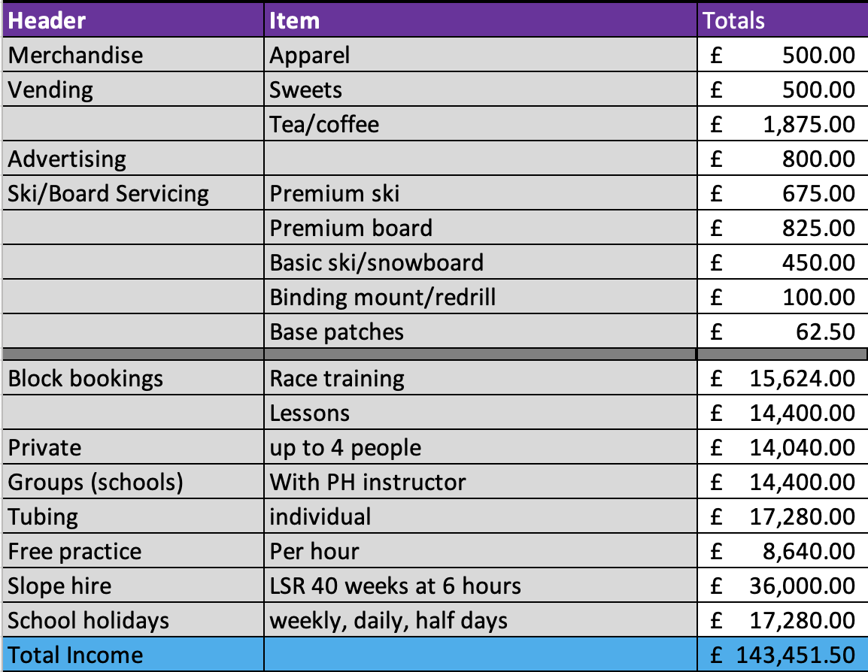
    - Please show your calculations of the costs associated with the transfer of the land or buildings and your future use of it, including any redevelopment, ongoing, maintenance and the costs of your activities. All proposed income and investment should be identified, including volunteering and donations.
We are committed to securing funding to bring the facility up to standard following years of underinvestment, with plans to apply for Falkirk Council’s Enablement Fund to address immediate building upgrades. Our financial strategy, set out in our accompanying business case, is designed to ensure both short-term and long-term sustainability. In the short term, operational costs will be covered by income from services, while we actively pursue capital funding to upgrade the buildings, replace the ski matting and introduce new features to enhance the Centre. As part of our long-term plan, once service levels increase, the ongoing replacement program, operational costs, and upkeep of the facility will be fully funded by revenue generated from our services, ensuring the Centre remains financially viable and continues to thrive.

The table above shows the projected first year’s income.

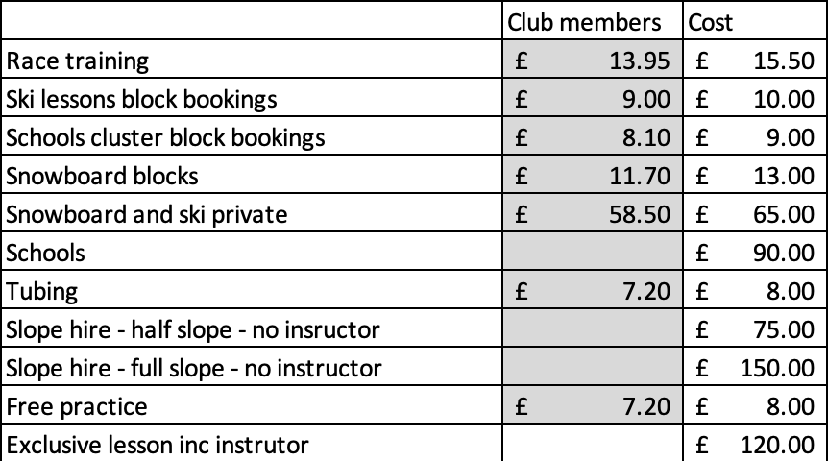

The table above shows our pricing schedule for slope time. Polmonthill Snowsports Club members will be offered a 10% reduction on lessons, tubing and practice to ensure members of the community can get best value prices, and encourage visitors to become regular customers and have a greater stake in the ongoing success of the Centre.
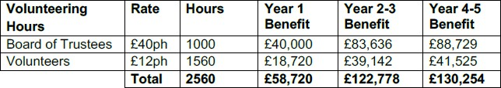

The above table shows the volunteer hours with benefit over 5 years
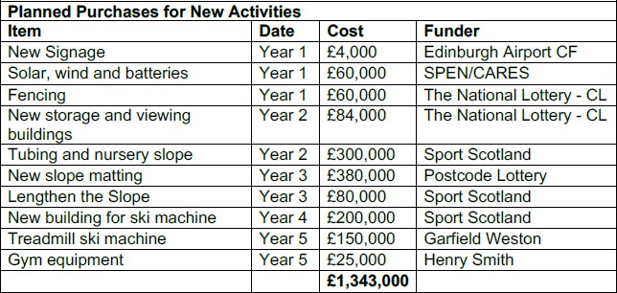

The table above shows the intended capital investment over 5 years with identified funding sources.


We will seek funding for our CAT conveyancing legal expenses from the National Lottery Awards for all. This funding must be spent within 1 year so we will submit our application once the CAT process has formally started.

The table above shows funding required for startup which has been requested through the Falkirk Council empowerment grant.



The table above shows the operation costs during the first year demonstrating a profit of £36,282.51
    - Please supply details of what funding you have received so far, and of any conditions attached to it.
So far, limited funding has been secured, as we do not yet own or have a lease agreement to manage and operate the facility. Additionally, most major funders require at least one year of financial accounts before considering significant investment and require any funding to be spent within one year of award. As a result, larger capital projects, such as the replacement of ski matting or the creation of a tubing slope, are planned for year two. However, we have already obtained some smaller funding shown below to cover professional services and start-up costs, enabling us to move forward with initial planning and development.
Falkirk Council Community Empowerment Grant CAT grant – awarded £3340

Community Ownership Support Service Expert Help Fund – awarded £1000

Ballie Gifford – awarded £1000

    - Please supply details of any funding you have applied for but have not yet received a response or decision. Please include timescales if known.
Safe Deposits Scotland Community Fund – requested £3284

Falkirk Council Community Empowerment Grant Capital grant – requested £8000

    - Details of any other funding you will have access to? i.e. voluntary contributions, borrowing etc.
None as yet

    - Please outline your funding strategy if you have one, as well as any other relevant information.

Operational Costs Covered by Ongoing Services
Self-Sustaining Operations: The organisation’s core strategy is to generate sufficient revenue from the ongoing services it provides, such as ski/snowboard lessons, equipment rentals, tubing, and café sales. This revenue is expected to cover all operational costs, including staff wages, utilities, maintenance, and day-to- day expenses.
Program Fees: Income from school programs, and holiday clubs will also contribute to meeting operational expenses, ensuring that the Centre remains financially viable from the outset.

Phased Capital Expenditure Plan
Initial Year with Limited Capital Outlay: During the first year, the organisation will focus on stabilising operations, maximising service-based income, and demonstrating strong financial management to build credibility. Capital expenditures will be kept to essential maintenance and small-scale improvements that can be funded through initial revenue and any small grants available without the need for extensive financial history.
Falkirk Council Enablement Fund: The funding strategy for the Polmonthill Community Snowsports Centre includes an important component: applying for support from Falkirk Council’s Enablement Fund in the first year. This fund is expected to provide crucial financial assistance to bring the existing buildings and facilities back to an acceptable standard following many years without investment. The Enablement Fund will be targeted specifically for essential repairs and upgrades, such as roof replacement, improving accessibility, and ensuring the buildings are safe, secure, and compliant.
Building Financial Reserves: Throughout the first year, the organisation will aim to build financial reserves from operational surpluses, which will not only provide a buffer for unforeseen expenses but also demonstrate financial stability to potential funders.

Leveraging Initial Grants and Community Contributions
Small Grants and Community Fundraising: The organisation will seek small grants and engage in community fundraising efforts during the first year to fund equipment purchases such as the purchase of additional ski equipment and tubing accessories. These smaller grants typically have lower thresholds for financial history and can help kickstart capital improvements.
Local Business Sponsorships: Partnerships with local businesses can provide sponsorships or in-kind contributions, such as materials or services, which will reduce the immediate capital expenditure burden.

Preparing for Major Capital Funding
Building a Track Record: By successfully managing operations and small-scale capital projects in the first year, the organisation will create a solid track record that will be documented in the first year’s accounts. This will be critical for approaching larger funders in subsequent years.
Comprehensive Capital Funding Applications: Once the first year’s accounts are available, the organisation will apply for significant capital funding from major grant- giving bodies. We have identified funding for which we will be eligible provided by Sport Scotland, the National Lottery, Business Energy Scotland and Local Energy Scotland and Scottish Landfill Communities Fund. These applications will be supported by detailed financial statements, a proven operational model, and clear plans for the capital projects.

Phased Capital Projects
Prioritisation of Projects: Capital projects will be prioritised based on their impact and the availability of funding. High-priority projects that are essential for safety, accessibility, or immediate operational enhancement will be tackled first as funding becomes available.
Strategic Long-term Improvements: Larger projects, such as slope extensions, new buildings, or significant infrastructure upgrades, will be planned for years two and three, aligning with the expected timeline for securing substantial capital funding.

Diversified Funding Sources
Grant Funding: The organisation will target multiple grant sources to diversify funding and reduce reliance on any single funder. This includes applying to both national and local funding bodies, as well as industry-specific grants related to sports, community development, and heritage preservation.
Corporate Partnerships: The organisation will seek partnerships with corporate sponsors, particularly those with an interest in sports, youth development, or community engagement, offering naming rights or other recognition in exchange for capital contributions.
Crowdfunding and Donations: Crowdfunding campaigns and appeals to individual donors, particularly those within the local community or with a connection to snowsports, will be launched for specific capital projects. This approach not only raises funds but also builds community support and involvement.

Demonstrating Impact and Sustainability
Monitoring and Reporting: The organisation will monitor the impact of its capital expenditures and report back to funders, demonstrating the effective use of funds and the tangible benefits to the community. This transparency will build trust and increase the likelihood of securing future funding.
Sustainability Plans: The funding strategy will include plans for maintaining and sustaining capital improvements, ensuring that once upgrades are made, they do not lead to unsustainable increases in operational costs.

Section 8. Enablement Fund
Falkirk Council will hand the building over wind and watertight and compliant. However, this is quite light-touch and would involve (for example) patching of a leaky roof. For more significant building works, groups can apply to the Enablement Fund, to pay for capital improvements such as energy efficiency improvements or larger capital renewals which support the viability of the project going forward. Only capital items are eligible. Running repairs are revenue costs and are not eligible. You are strongly advised to email strategicpropertyreview@falkirk.gov.uk to confirm eligibility criteria before you submit this application.
Requests to the Fund must be supported by estimates / quotations from professionals which should be provided as supporting documents.

Please provide details of your request to the Enablement Fund, if applicable.
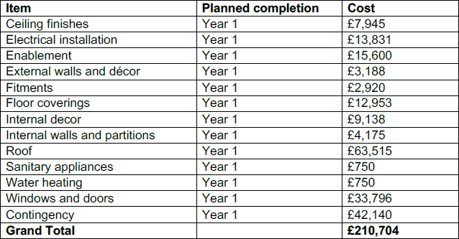

The table above shows the funds required from Falkirk Council’s Enablement Fund to bring the facility up to standard following years of underinvestment and subsequent decline.

Checklist of accompanying documents

To check that nothing is missed, please tick which additional documents are accompanying this form.
- Section 1 – You must attach your organisation’s constitution, articles of association or registered rules. Attached.
- Section 2 – Any maps, drawings or description of the land requested. Included in this document.
- Section 3 – Note of any terms and conditions that are to apply to the request. N/A

- Section 4 – Any additional evidence regarding your proposals, their benefits, any restrictions on the land or potential negative consequences, and your organisation’s capacity to deliver. N/A
- Section 5 – Evidence of community support. Attached.

- Section 6 – Financial – Copies of accounts, forecasts, etc. Attached.

- Section 7 – Funding – Copy of Business Case etc. Attached.

- Section 8 – Enablement Fund – copies of estimates. Attached.

Declaration
Two office-bearers (board members, charity trustees or committee members) of the community transfer body must sign the form. They must provide their full names and home addresses for the purposes of prevention and detection of fraud.
This form and supporting documents will be made available online for any interested person to read and comment on. Personal information will be redacted before the form is made available.

We, the undersigned on behalf of the community transfer body as noted at Section 1, make an asset transfer request as specified in this form.
We declare that the information provided in this form and any accompanying documents is accurate to the best of our knowledge.
Name Address

Date Position Signature

Name Address

Date Position
Signature

